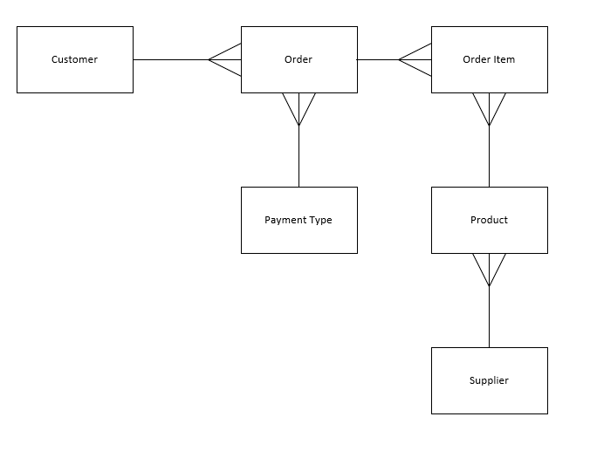

Has an Appears on

Makes an Is made by

Supplied By

Supplies

Records

Used on

Represents

Appears as